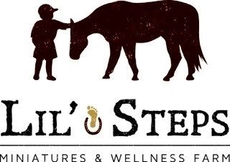
Contact Person: Lucy Fouasse
Address: Box 121, St. Malo, Manitoba, R0A 1T0
Email: lilstepsfarm@gmail.com
Phone: #204-298-7142
Website: lilstepswellnessfarm.net

LIL’ STEPS WORKSHOP REGISTRATION
CHILD’S NAME: ________________________________________________________
ADDRESS: ____________________________________________________________
CITY: ___________________PROVINCE:_______ POSTAL CODE: ______________
AGE: __________
PARENT’S/GUARDIAN’S NAME: __________________________________________
HOME PHONE: _____________________CELL PHONE: ______________________
EMERGENCY CONTACT: __________________RELATIONSHIP: ______________

PHONE NUMBER: ________________EMAIL: _________________________

MEDICATIONS? _______________________________________________________
ANIMAL ALLERGIES? __________________________________________
CHECK THE FOLLOWING DATE(S) YOUR REGISTERING FOR:
____ April 3, 10, 24th and May 1st, 2016 from 10am-noon (ages 6-8)
____ April 3, 10, 24th and May 1st, 2016 from 10am-noon (ages 9-13)

COST: $131.25 includes GST CIRCLE ONE: ____ CASH _____ CHECK

