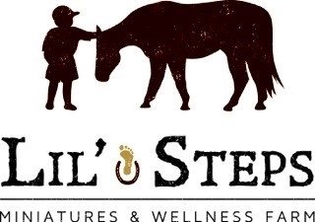
Contact Person: Lucy Fouasse
Address: Box 121, St. Malo, Manitoba, R0A 1T0
Email: lilstepsfarm@gmail.com
Phone: #204-298-7142
Website: lilstepswellnessfarm.net

Permission Form for Pictures

CHILD/STUDENT NAME: __________________________________

I GIVE MY PERMISSION to Lil’ Steps Miniatures and Wellness Farm; while my child or youth in my legal care is attending the Equine Facilitated Wellness Programs, to take and use photographs at their discretion, inasmuch as the reproductions are in good taste and respectfully displayed.

NAME OF PARENT/GUARDIAN OF PARTICIPANT UNDER 18 YEARS OF AGE:

PRINT: _________________SIGNATURE: ________________________

DATE: _______________________________

Please inform us if you are not comfortable with your child being in photographs and we will accommodate your request.

