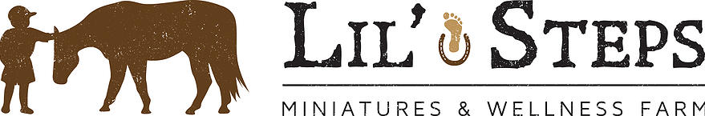

Acknowledgement of Risk and Release of Liability
Lil’ Steps Miniatures and Wellness Farm
For participants under eighteen (18) years old in Manitoba
I, _______________________________________, parent/guardian to ______________________________, understand this is a waiver of all claims, release from all liability, assumption of all risks, and agreement to not sue by me for the benefit of Lucy Fouasse and all employees/volunteers of Lil’ Steps Miniatures and Wellness farm during Equine/Animal Facilitated Wellness programming.
Initial each item after you have read and understood it:
- _______ I am the parent/guardian of _____________________. I am signing this waiver on behalf of my child with the intent this waiver is binding on me and my child for all legal purposes.
- _______ I am aware that inherent dangers, hazards, and risks are associated with equine and animal activities and are a common occurrence.
- _______ I accept and assume all responsibility for all risks and possibilities of any personal injury, death, property damage or loss resulting from my child’s participation in the animal assisted programs.
- _______ Although Lil’ Steps Wellness Farm has dedicated themselves to providing a safe environment for your child; I understand it is not possible for the host to make the equine facilitated wellness programs completely safe. I accept these risks and agree to the terms of the waiver on behalf of my child, even if the host is found to be negligent or in breach of any duty of care.
- _______ I agree that this waiver and all its terms are governed by the laws of Manitoba and no other province or territory. Any litigation to enforce this waiver will be done in Manitoba.
- _______ I understand this agreement represents the entire agreement among the host, me (as the parent/guardian), and the child.
- _______ I confirm I have read and understood the waiver, and I have asked the host to clarify any points I was unsure of.
Print: Name of Participant Under Age 18 ________________________________________________
Date of Birth: ______________________________________________________________________________
Print: Name of Parent/Guardian _________________________________________________________
Street Address, City, Province ____________________________________________________________
Phone number: ( ) __________________________________________________________________
Signature of Parent/Guardian and Date: ________________________________________________
Print: Name of Witness ____________________________________________________________________
Signature of Witness and Date: ___________________________________________________________

